Studio 09

Junyan Wang - 28695313

Self-Evaluation {To be highlighted by Student only}:

|  |  |  |  |  |  |
| --- | --- | --- | --- | --- | --- |
| Need Help | Work in Progress | Pass | Credit | Distinction | High Distinction |

Tutor Evaluation {To be highlighted by Tutor only}:

|  |  |  |  |  |  |
| --- | --- | --- | --- | --- | --- |
| Incomplete | Needs improvement | Pass | Credit | Distinction | High Distinction |

Task {2.1}:

{Answers}

Property.java

//Make it as an entity.

@Entity

// created for ejb to use

@NamedQueries({@NamedQuery(name = Property.GET_ALL_QUERY_NAME, query = "SELECT p FROM Property p")})

// define pk

@Id

Detail.xhtml && Index.xhtml

Please check the link below, I have uploaded the code into github.

{Screenshots}

Property list feature:

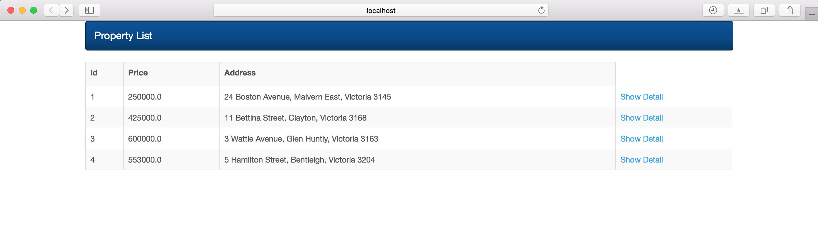

Property details feature:

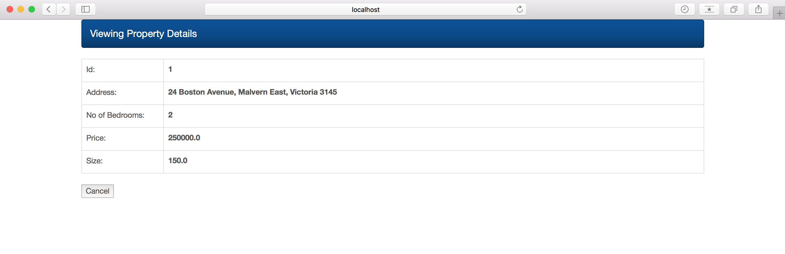

{Link to code repository}

Task 2-1: <https://github.com/junyanwang0102/FIT5042_Tutorial/tree/master/Task%202-1>

Task {2.2}:

{Answers}

Please check the below link to the git repository. Basically, I followed the steps in the exercise specification and change the validation information.

{Screenshots}

The validation messages on the index page

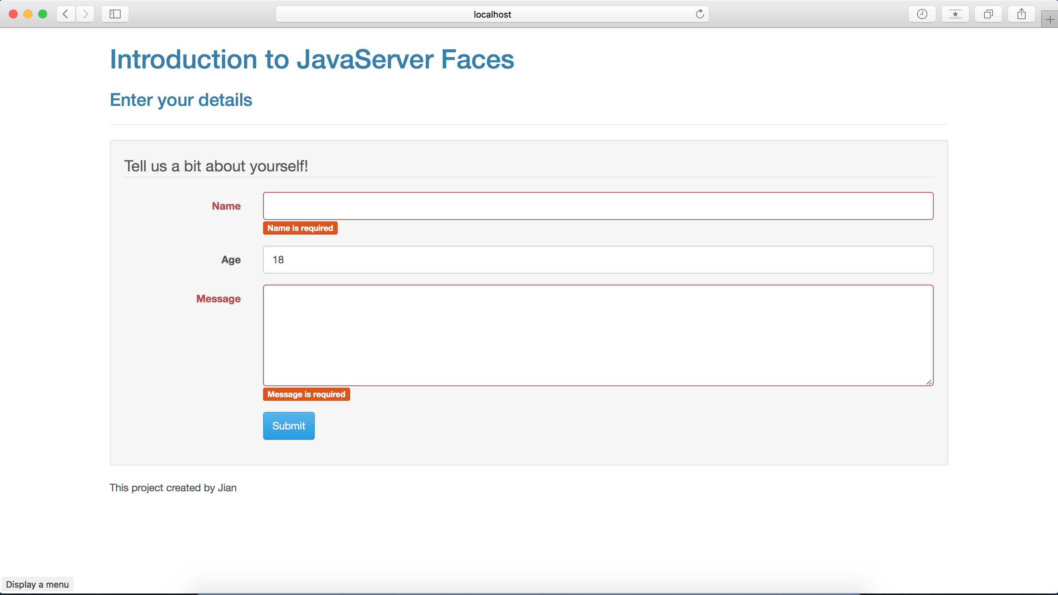

The response page

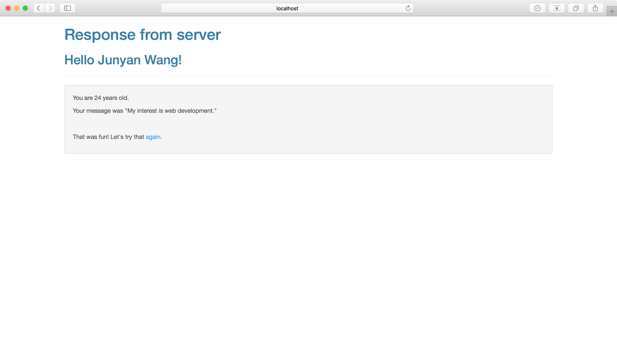

{Link to code repository}

Task 2-2: <https://github.com/junyanwang0102/FIT5042_Tutorial/tree/master/Task%202-2>